Contents
HOLY TRINITY CATHOLIC PRIMARY SCHOOL
Eltham North
REGISTERED SCHOOL NUMBER: 1910

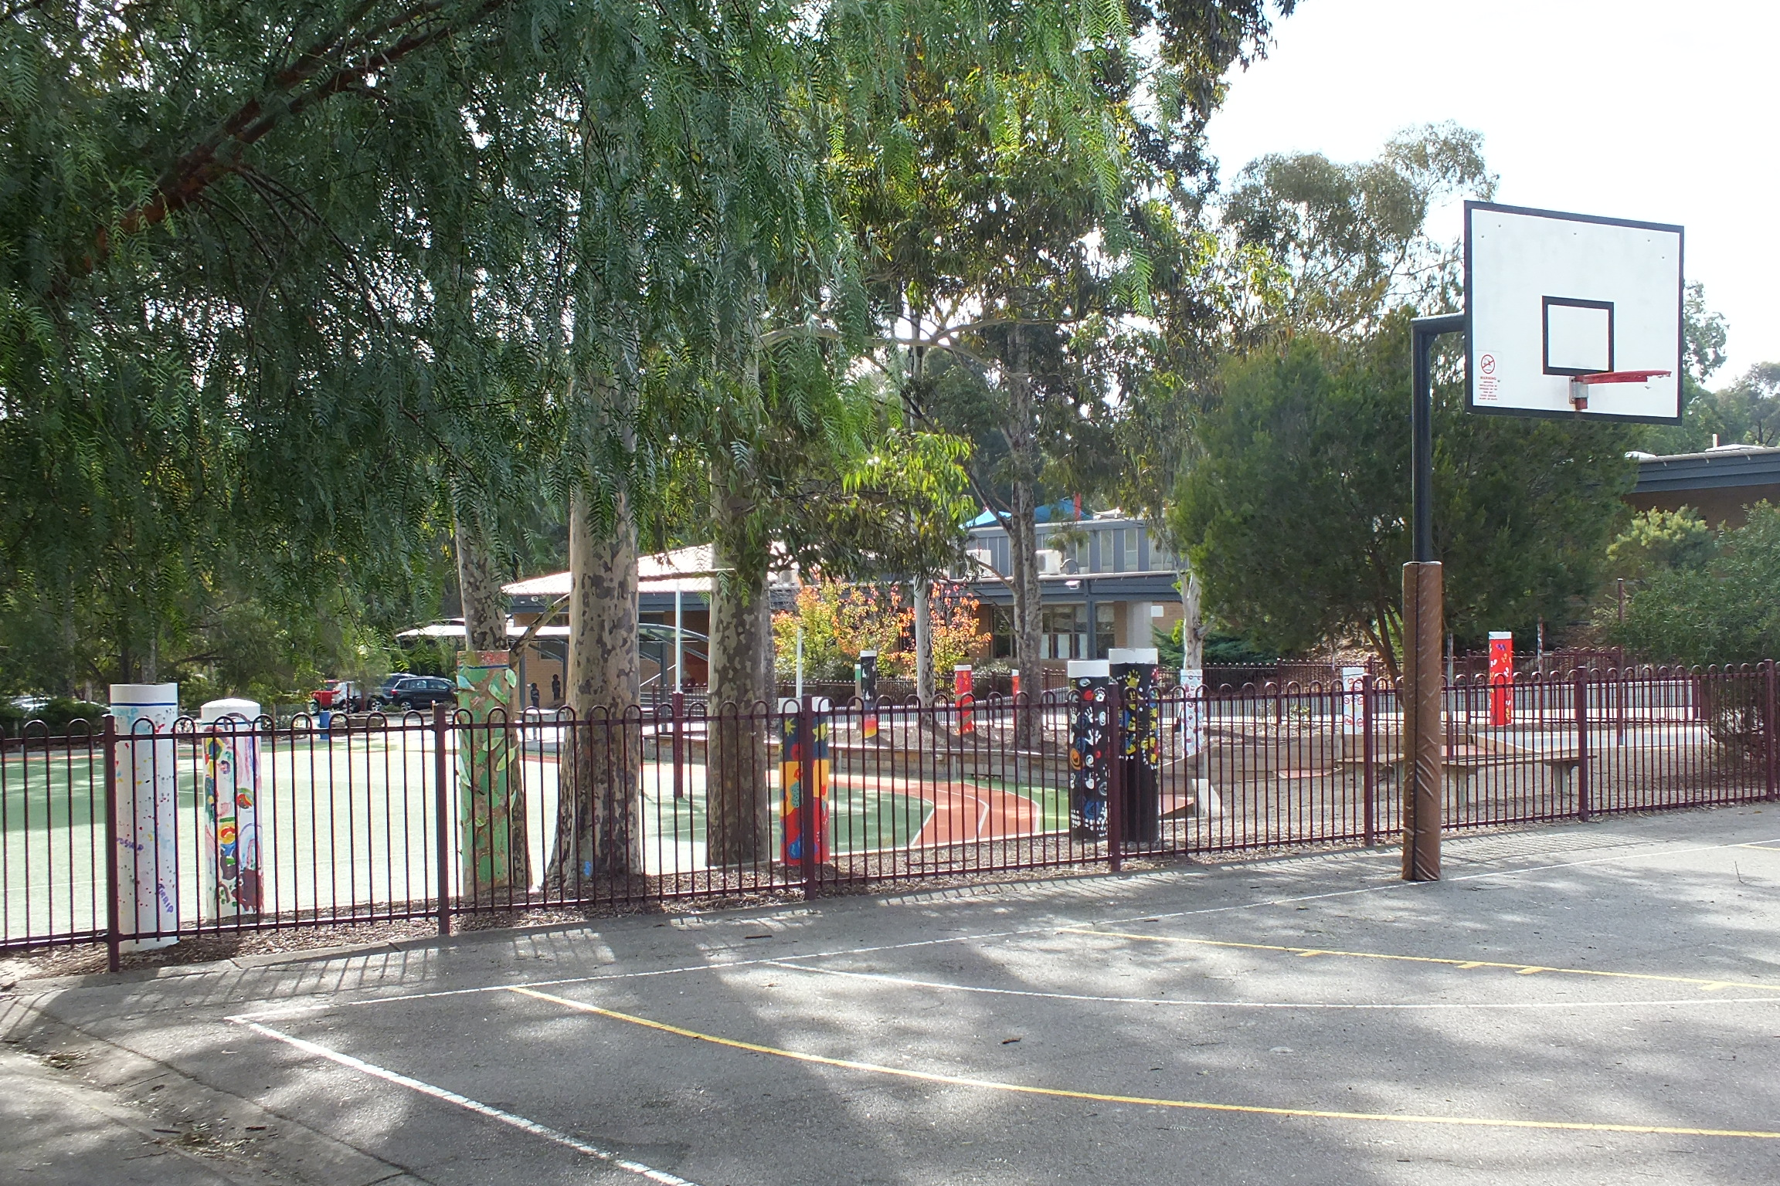
2018
ANNUAL
REPORT
TO THE SCHOOL
COMMUNITY
Contact Details 2
Minimum Standards Attestation 2
Our School Vision 3
School Overview 4
Principal’s Report 5
Education in Faith 6
Learning & Teaching 8
Student Wellbeing 13
Child Safety 16
Leadership & Management 18
School Community 20
Future Directions 22
School Performance Data Summary 23

Contact Details
ADDRESS | 94 Weidlich Road  Eltham North VIC 3095
PRINCIPAL | Mr Vince Bumpstead
PARISH PRIEST | Fr Terry Kean
SCHOOL BOARD CHAIR | Mr Mark O’Dowd
TELEPHONE | (03) 9431 0888
EMAIL | principal@htelthamnth.catholic.edu.au
WEBSITE | www.htelthamnth.catholic.edu.au
E NUMBER | E1346

Minimum Standards Attestation
I, Vince Bumpstead, attest that Holy Trinity Catholic Primary School is compliant with:
- All of the requirements for the minimum standards and other requirements for the registration of schools as specified in the Education and Training Reform Act 2006 (Vic) and the Education and Training Reform Regulations 2017 (Vic), except where the school has been granted an exemption from any of these requirements by the VRQA
- Australian Government accountability requirements related to the 2018 school year under the Australian Education Act 2013 (Cth) and the Australian Education Regulations 2013 (Cth)
May 2019

Our School Vision
Our School Vision Statement

Holy Trinity Catholic Primary School
is a faith community inspired by the love of God, within the Parish of St Francis Xavier.

We strive to create a positive and collaborative learning community that inspires all to reach their full potential living justly and compassionately within a global community

LIVE – be involved
LOVE – be inclusive
LEARN – be enlightened
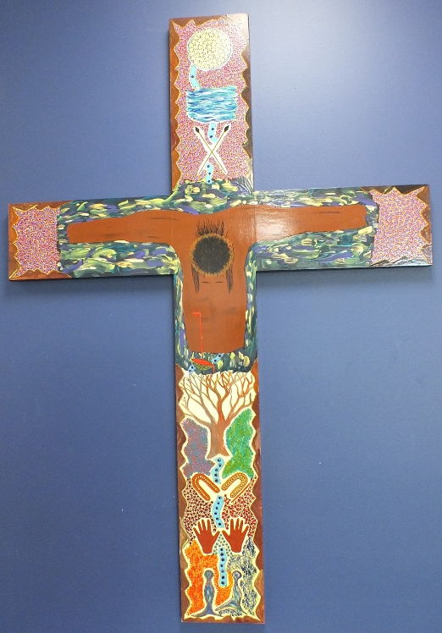
and embrace God’s word

School Overview
Holy Trinity Catholic Primary School opened in 1987 as the second primary school in the Parish of St Francis Xavier in Montmorency. It is a two stream school with two classes in each level. In 2018 Holy Trinity had 388 students.
During 2018 we started to work in the areas identified by our School Review process in 2017. These were:

Learning & Teaching: To develop a learning environment where learning is personalised and all students and staff are challenged and supported to achieve ongoing improvement, success and engagement.

Education in Faith: To nurture and encourage the development of our Catholic faith and the spirituality and mission of each person within the Holy Trinity school community
Student Wellbeing: To foster a positive school and classroom environment.
Leadership & Management: To develop a vibrant, empowering professional culture based on collaboration, openness and trust reflective of our Catholic context.
Community: To improve connectedness and student learning and wellbeing outcomes through collaborative, purposeful partnerships between the school, parish and the wider community.
We continued to improve the professional knowledge of our staff by working with world renowned experts in the field of ‘Cultures of Thinking’, such as Professor Ron Ritchhart. Through these Professional Learning activities, our teaching staff are challenging our students to deepen their thinking, as well as develop effective collaboration skills.
We continue to link our Social Justice to our Catholic Tradition. Our students understand that our Faith story calls us to action: not just because it is the right thing to do, but more so because our Catholic Story is one of helping those who are less fortunate than ourselves. Our relationship with our Friendship School in the Philippines continued, with Holy Trinity taking on a new friendship school due to the success and improvement of our previous school. We now support San Rafael, a school which is in its early stages of development. We hope that it too, can become a sign of hope for the students in the surrounding areas.

Principal’s Report
In 2018 Holy Trinity began to implement the recommendations from our School Review in 2017. A great emphasis was placed on achieving a minimum of 12 months growth for all students in all areas. This required professional learning with the staff to define what this improvement would look like, how it would be assessed and how it would be monitored. The use of data in informing teaching was also reinforced.
Holy Trinity has continued to be a Fire Carriers School where our aboriginal history and heritage is highlighted and celebrated. The Class Totem poles have again been a focus for the beginning of the year. This has enabled each class to explore their particular totem and how it relates to them.
We continued our work with Professor Ron Ritchhart in the area of Cultures of Thinking. This has further embedded these practices into the classroom routines.
Holy Trinity has continued to have a strong parent school partnership. This was reflected by the strong participation in Parents Committee and Works and Maintenance Committee. Strong parent support in the classroom ensured that our students were well supported. The support through the Bridges Program and Sport coaches has been greatly appreciated.
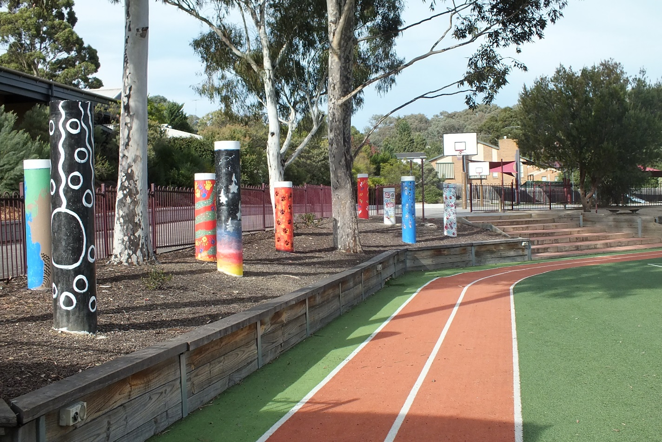

Education in Faith

Goals & Intended Outcomes
- To nurture and encourage the development of our Catholic faith and the spirituality and mission of each person within the Holy Trinity school community.
- That students and staff make meaningful connections between their lives and actions, and the Catholic faith.

Achievements
- Sacramental Program combined with our sister school St Francis Xavier, Montmorency.
- Sacramental Workshop Days for First Eucharist and Confirmation combining with SFX
- Organised guest speaker
- Faith Nights for Sacramental Years 2, 3 and 6.
- Faith Night for Prep year level-Preps in Pyjamas (well attended)
- Class Masses have continued to be highly attended and prayerful celebrations.
- Year 2 excursion to SFX church and tour of the church led by Pastoral associate and RE leader.
- Whole School Masses for Feast day and beginning and end of year Mass
- Staff masses celebrated at the beginning and end of school year with staff of SFX
- Christian Meditation every morning in classrooms
- Guided Meditation Professional Development for students and staff provided by Jude Casperz. Guided Meditation introduced to Christian Meditation sessions approximately once per week and as an option in classes
- Christian Meditation run every Thursday during the second half of lunch by the RE Leaders
- Advent liturgies led in classrooms by the RE Leaders-Thinking routines used for activities
- Easter Alleluia Mass
- Easter Walk carried out by the whole school. Students were required to produce an art piece from an event in Holy Week.
- Year 6 RE Leaders attended the Kids View Conference. This was used as a lead in to run a combined school Social Action Day with SFX.
- Grandparents/Special Persons Day liturgy
- Grandparents/Special Persons Day donations of cans of food were brought by families for families in need to be donated to St Vinnies for distribution to the community. We held a Devonshire tea for visitors in the Library. Was well attended and much gratitude was shown for the day.
- Assumption of Mary- Prayer space set up in the Sacred Space to honour this Feast day
- Feast Day of St Mary Mackillop- Prayer space set up in the Sacred Space to honour this Feast day. RE leader ran 40 minute sessions with each year level highlighting St Mary Mackillop
- Continued development of Hermeneutical planning of RE units by staff as well as the continued implementation of the new RE Framework. Teachers implemented its use in planning and used for reporting against the learning descriptors and progression.
- One RE Professional Learning Meeting was given per term
- RE concepts combined with Student Well-being concepts continued to be used to assist with planning
- Re-introduced a new version of the Prayer Scope and Sequence for all year levels. Preps were given a Prayer book at their faith night.
- Prayers carried out before meetings
- RE news and links made in newsletters
- Social Action day led by Year 6 student leaders and teachers on the Social Justice Committee
- Balikbayan boxes packed and sent to our friendship school - old books from library, toiletries collection, donations etc.
- Continued to collect for St Vincent de Paul for the Christmas appeal, collections were also made as a Eucharist group action and for our annual Grandparents/Special Persons Day
- Purchase of new school banners and altar cloths with school logo
- Graduation mass continued to be held at SFX church and dinner at the SFX hall
- Prayer table placed in staff foyer to highlight our Catholic identity and liturgical seasons by the use of the coloured cloths
- Use of Liturgical Lamps in school foyer and Sacred Space, highlighting Feast days, Sacraments and liturgical seasons.
- Photos placed in foyer of Sacramental groups
- Class masses celebrated in classrooms.
- Continual update of scripture resources for classrooms

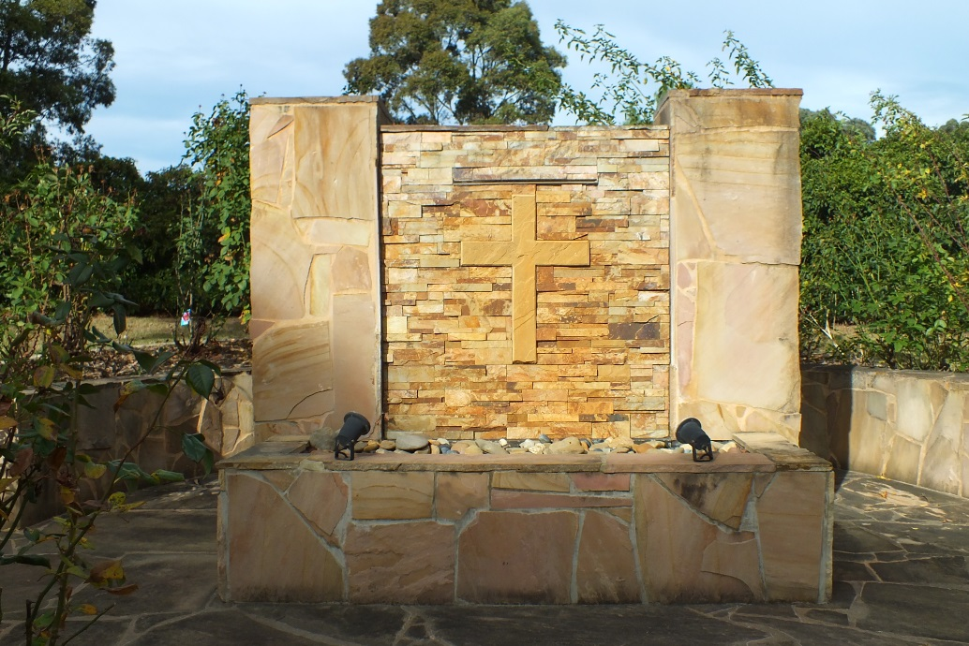

Learning & Teaching

Goals & Intended Outcomes
To develop a learning environment where learning is personalised and all students and staff are challenged and supported to achieve ongoing improvement, success and engagement. That literacy and numeracy outcomes will be improved.
- That individual and student cohort growth be maximised.

Achievements
We acknowledge that our school’s ability to maintain a 100% achievement of minimum standards indicates a strong learning culture
PROPORTION OF STUDENTS MEETING THE MININUM STANDARDS
NAPLAN TESTS | 2016  % | 2017  % | 2016 - 2017  Changes  % | 2018  % | 2017 - 2018  Changes  %
YR 03 Grammar & Punctuation | 100.0 | 100.0 | 0.0 | 100.0 | 0.0
YR 03 Numeracy | 100.0 | 100.0 | 0.0 | 100.0 | 0.0
YR 03 Reading | 100.0 | 98.1 | -1.9 | 100.0 | 1.9
YR 03 Spelling | 100.0 | 100.0 | 0.0 | 100.0 | 0.0
YR 03 Writing | 100.0 | 100.0 | 0.0 | 100.0 | 0.0
YR 05 Grammar & Punctuation | 98.1 | 98.1 | 0.0 | 100.0 | 1.9
YR 05 Numeracy | 100.0 | 100.0 | 0.0 | 100.0 | 0.0
YR 05 Reading | 100.0 | 100.0 | 0.0 | 100.0 | 0.0
YR 05 Spelling | 98.1 | 100.0 | 1.9 | 100.0 | 0.0
YR 05 Writing | 98.1 | 100.0 | 1.9 | 100.0 | 0.0

 | 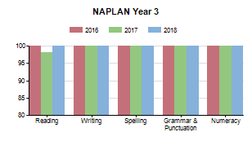 |  | 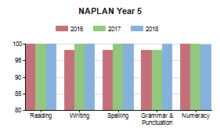
STUDENT LEARNING OUTCOMES
READING
YEAR 3
In 2018, 83% of Year 3 students reached the top two bands 5 & 6 in reading.

YEAR 5
In 2018, 77% of Year 5 students reached the top two bands 7 & 8 in reading

WRITING
YEAR 3
In 2018 87% of Year 3 students achieved in bands 5 & 6 in writing

YEAR 5
In 2018, 33 % of the year 5 students achieved in Band 7 & 8 in writing

SPELLING
YEAR 3
In 2018, 80 % of Year 3 students reached the top two bands 5 & 6 in spelling

YEAR 5
In 2018 56% of year 5 students reached the top two bands in spelling

NUMERACY
YEAR 3
In 2018, 71 % of year 3 students reached the top two bands, 5 & 6 in Numeracy

YEAR 5
In 2018, 67% of year 5 reached the top two bands, 7 & 8 in Numeracy
VALUE ADDED
Holy Trinity has continued to offer a variety of practices and programs to enhance student learning. These include:
- Professional learning in the areas of Literacy, Mathematics and Inquiry Learning, has been undertaken by all staff to continue to extend, develop and consolidate knowledge of effective teaching strategies and tools. This professional learning has been both school based and external
- Continued implementation of Learning Intentions and Success Criteria in all curriculum areas
- A term by term review process is undertaken with the staff and Leaders in the school. These meetings are designed to assess the needs of staff, to set and project learning goals in line with the Victorian Standards for Learning and Teaching.
- Weekly Professional Action Learning Meetings
- Development of Inquiry approach continued to be an important focus within the classrooms. Teacher planning days return to full day once per term to examine data to inform the planning
- Introduction of Staff meeting prior to planning days for the explicit attention to RE, Catholic Social Teachings and Horizons of Hope to drive planning
- Introduction of Horizons of Hope statements as the guiding influence for Inquiry process. Staff Professional dialogue and development of Curriculum using Horizons of Hope
- Introduction of Berry Street Program for staff and students
- Professional Learning Meeting to analyse NAPLAN Data to inform teaching
- Professional learning continuing with RE framework and RE scope & sequence
- Professional Learning unpacking and using Horizons of Hope Catholic Education Melbourne (CEM) documentation
- Specialist Programs in Physical Education, Language Other Than English (Italian), Performing Arts and Library
- Science, Technology, Engineering and Mathematics (STEM) program continued
- Participation in the CEM STEM Mad showcase
- Professional Learning in Digital Technologies
- Continued use of Google Docs with staff in 2018
- See Saw app introduced for Prep – Year 2 reporting work samples
- Professional learning in Visual Arts
- Established non-negotiable requirements in Literacy and Numeracy. Continued development of consistent representation of the non-negotiable requirements in planning documentation across all levels of the school

- Explicit reference to student data for planning and implementation of Literacy and Numeracy programs
- Continued Literacy Support, Mathematics Intervention, Reading Recovery and the Bridges Program were offered to students identified as requiring extra assistance in meeting their learning goals
- Education Support Employees continue to provide valuable assistance in meeting the needs of students requiring additional support in all areas of school life
- Literacy and Numeracy programs have been offered to students identified as requiring extension in their learning. These include Literacy Bridges program, Australian Mathematics Competition, Australian Mathematics Challenge, Extending Mathematical Understanding (EMU) Program and an Inter-school Mathematics Tournament
- Levelled Literacy Intervention (LLI) program with a small group of students across years 2-6
- Continuation of LLI program across whole school Foundation – Year 6
- Introduction of Rubric development for assessment for, as and of learning
- Focus on Visible learning , Learning intentions, Success Criteria and Anchor Charts
- Regular Program Support Group (PSG) meetings with parents, school staff and outside educational agencies facilitated for students requiring additional support
- The Literacy and Mathematics Parent Helper Course was well attended and has been valuable for informed parent participation in the classroom
- Student Leadership programs to promote student voice and engagement were continued. These included Student Class Leaders, School and House Captains and Student Curriculum Leaders
- Leadership workshops -Kate Wilde- provided for Year 6 students to develop Leadership skills
- Professional learning - Victorian Curriculum
- Externally provided Instrumental Music Program through Metro Music
- St John’s First Aid training for students
- 3 days Professional Learning with Professor Ron Ritchhart in the area of making Learning visible
- Introduction of Coaching
- Nationally Consistent Collection of Data (NCCD) professional learning
- Ongoing professional Learning and implementation of LLI program
- Zoos’ Victoria Project initiative (2 staff)
- Introduction of STEM learning- STEM capabilities Year 5, 6 & 2
- Commitment to Fire Carrier Program in School and in curriculum planning
- Professional Learning offered to staff in form of Aboriginal immersion program at Lake Mungo NSW
- Student Fire Carriers representatives attend Fire Carrier days at Mary Immaculate Ivanhoe
- Fire carrier Professional Learning day offered 2018
- Fire Carrier Professional Learning- Two Way Cross

- Staff continue to upgrade their safety procedures participating in School Emergency professional learning and drills
- Graduate Program for Graduate teachers
- Outdoor Education Program - The Briars Year 5 Camp
- Sovereign Hill extended day excursion for Year 5
- Outdoor education- Canberra camp Year 6
- Administration staff attended professional learning days
- School Leaders are supported to attend network Professional Learning meetings, enhancing leadership skills and knowledge
- Introduction of phase 2 of the Leading Languages Professional Learning Program (LLPLP) LOTE Initiative

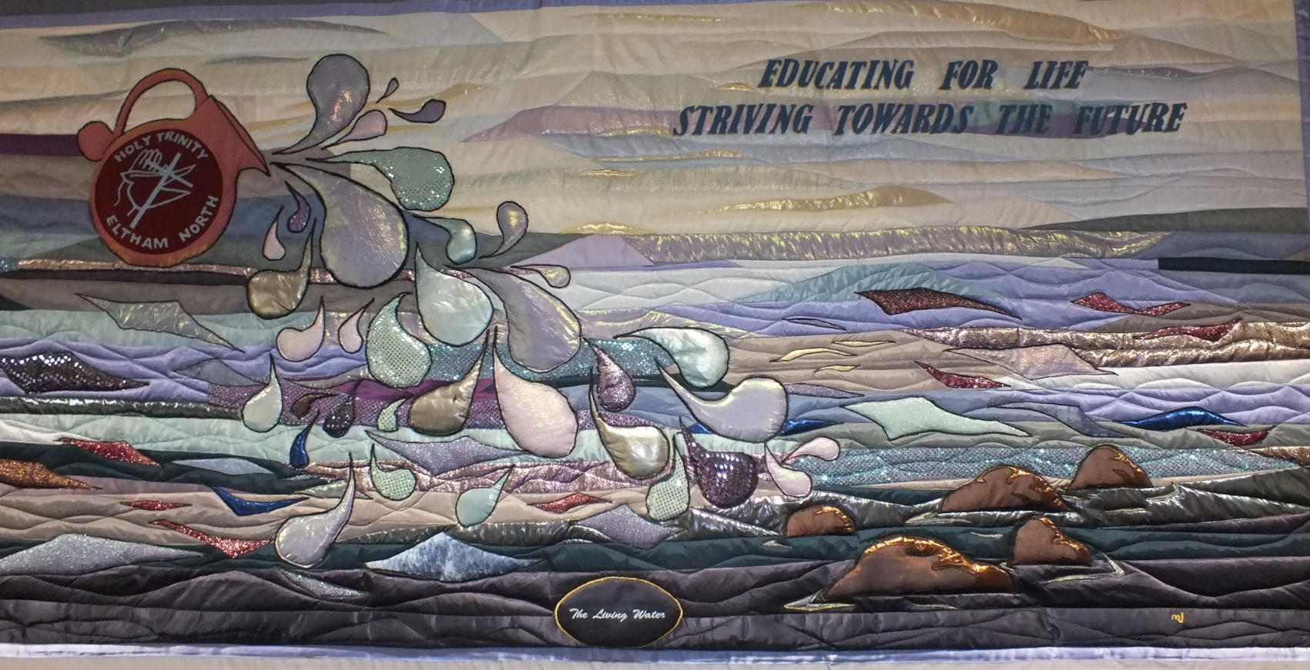

Student Wellbeing

Goals & Intended Outcomes

Goal:
To foster a positive school and classroom environment.

Intended Outcomes:
- That our students develop as empowered, engaged and autonomous learners and leaders.
- Continue to ensure a consistent whole school approach to the delivery of the student wellbeing practices.
- Continue to build a link between student wellbeing practices and Catholic identity.

Achievements

- Reinforcement of the 5 core values for Holy Trinity in line with the Catholic Social Teaching Principles
- Wominjeka week - a Wellbeing focus for the first 3 days of school was trialled
- All staff attended day 1 of the Berry Street Education Model : Body Domain
- ‘You Can Sit with Me’ kindness campaign was implemented by the Student Wellbeing Leaders
- Our Respectful Relationships journey continued
- Student voice was collected to create a more equal uniform policy with summer and winter options rather than gender specific options
- The Resilience, Rights and Respectful Relationship curriculum was introduced over a 2 year cycle.
- Staff attended professional learning about the Resilience, Rights and Respectful Relationship curriculum
- All staff were invited to attend professional learning about Responding to Disclosures as part of the Respectful Relationships initiative.
- Guest speaker from the Bully Zero foundation came out to Holy Trinity to run workshops with our Years 3-6 students
- Interrelate Family services were outsourced to present our Puberty Education. Evening Workshops for families and students from Years 3-6 were run. Follow up student sessions were held for both Year 5 and Year 6 students within the classroom
- The Holy Trinity Student Code of Conduct was sent home to all families
- All Year 6 students participated in a series of Leadership workshops facilitated by Kate Wilde
- Professional development undertaken by the Student Wellbeing Leader in the Berry Street Educational Model and the Respectful Relationships Initiative and the PROTECT document and procedures
- Wellbeing Leader continuing to support classroom teachers with resources teaching strategies for social and emotional learning
- Wellbeing Leader continuing to meet with parents and students with Social Emotional Learning (SEL) concerns
- All teachers continue to use online platform (nForma) wellbeing to track all students with SEL needs across all year levels

VALUE ADDED
- Termly Student Wellbeing Support Group meetings for all classroom teachers to meet with the Student Wellbeing Team consisting of the Student Wellbeing Leader, Students with Additional Needs Leader, Literacy Leader, Numeracy Leader and Learning and Teaching Leader to discuss students with social and emotional needs and other learning needs
- Continuation of the following Social and Emotional Learning Programs:
  - You Can Do it
  - Bounceback
  - Values Education
  - Family Life Victoria
  - Life Education
- Resilience, Rights and Respectful Relationships
- Lunch–time clubs continued – LOTE, ICT, Library, Christian Meditation, Friendship club
- Student leaders presenting Student Wellbeing Awards at assembly
- Continuation of the Prep-Year 6 Buddy program
- Prep - Year 6 buddy family picnic to introduce our new families to the school early Term 1

STUDENT SATISFACTION
Each year our Year 5 & 6 students along with a representative of Parents complete an Insight SRC survey. The following are reflections on some of the results.

Student Safety:
The Parent Survey on student safety decreased from 74 (2017) to 70 (2018).
The Student survey on student safety decreased from 78 (2017) to 75 (2018).

Connectedness to School
The Parent Survey on ‘Connectedness to School’ remained the same from 2017 to 2018 (80)
The Student Survey on ‘Connectedness to School’ decreased slightly from 82 (2017) to 81 (2018).

Student Moral
The Students Survey on ‘Student Morale’ decreased slightly form 70 (2017) to 69 (2018)

AVERAGE STUDENT ATTENDANCE RATE BY YEAR LEVEL | %
Y01 | 93.4
Y02 | 94.3
Y03 | 94.0
Y04 | 93.9
Y05 | 93.5
Y06 | 91.7
Overall average attendance | 93.5

STUDENT ATTENDANCE
- Non-attendance has not been an issue in the past year

School attendance is marked on the electronic roll each school day in the morning and the afternoon. Each Semester, any days of non-attendance are marked on the school reports. As written in the Holy Trinity Parent Handbook, all absences from school require a note from the parents explaining the absence upon his/her return to school. If a child is absent from school and notification from the parents has not been received, the parents will be contacted by 9.30 am to explain the absence of their child.
If a teacher has any concerns about the attendance of any student, they bring this to the attention of the Principal, who will contact the parents to seek clarification for the student’s non-attendance. If the student’s non-attendance is still a concern, a formal meeting with the parents will be arranged to discuss these concerns.

Child Safe Standards

Goals and Intended Outcomes
At Holy Trinity we hold the care, safety and wellbeing of children and young people as a central and fundamental responsibility of our school. Our commitment is drawn from and inherent in the teaching and mission of Jesus Christ, with love, justice and the sanctity of each human person at the heart of the Gospel
Purpose of the Policy
The purpose of this policy is to demonstrate the strong commitment of Holy Trinity to the care, safety and wellbeing of all students at our school.
It provides an outline of the policies, procedures and strategies developed to keep students safe from harm, including all forms of abuse in our school environment, on campus, online and in other locations provided by the school.
This policy takes into account relevant legislative requirements within the state of Victoria, including the specific requirements of the Victorian Child Safe Standards as set out in Ministerial Order No. 870.
This policy applies to school staff, including school employees, volunteers, contractors and clergy.

Principles
Holy Trinity has a moral, legal and mission-driven responsibility to create nurturing school environments where children and young people are respected, their voices are heard and they are safe and feel safe.

The following principles underpin our commitment to child safety at Holy Trinity:
- All students deserve, as a fundamental right, safety and protection from all forms of abuse and neglect.
- Our school works in partnership with families and the community to ensure that they are engaged in decision-making processes, particularly those that have an impact on child safety and protection.
- All students have the right to a thorough and holistic education in all aspects of personal safety, in partnership with their parents/guardians/caregivers.
- All adults in our school, including teaching and non-teaching staff, clergy, volunteers, and contractors, have a responsibility to care for children and young people, to positively promote their wellbeing and to protect them from any kind of harm or abuse.
- The policies, guidelines and codes of conduct for the care, wellbeing and protection of students are based on honest, respectful and trusting relationships between adults and children and young people.
- Policies and practices demonstrate compliance with legislative requirements and cooperation with the Church, governments, the police and human services agencies.
- All persons involved in situations where harm is suspected or disclosed must be treated with sensitivity, dignity and respect.
- Staff, clergy, volunteers, contractors, parents and students should feel free to raise concerns about child safety, knowing these will be taken seriously by school leadership.
- Appropriate confidentiality will be maintained, with information being provided to those who have a right or a need to be informed, either legally or pastorally.

Achievements
- Holy Trinity Primary School has always been committed to the highest standards of child safety and has a zero tolerance for child abuse. Every member of the school community, including staff, parents, volunteers, contractors and students have an important role in helping children be safe.
- As a School we have used the introduction of the new Victorian Child Safe Standards as an opportunity to review all the School’s policies and practices regarding the School’s care, safety and welfare of children. The new Child Safe Standards go further than previous child protection arrangements and apply to all School community members including volunteers and contractors, visitors and students’ family members as well as students over 18 years of age.
- The Child Safe Code of Conduct and Child Protection Risk Management Strategy were presented to the School Advisory Board on Wednesday 20th July, 2016.
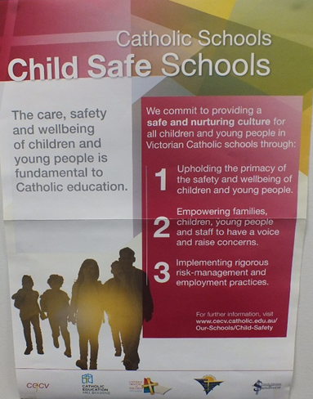
- A new Code of Conduct for all members of the School Community and Child Safety Code of Conduct, have been introduced which are available on the school website and a hard copy in the office. All staff have signed the new Code of Conduct and we are implementing a process whereby all contractors and volunteers will be required to agree to the Code of Conduct on entry to the school at the visitor sign in located next to the office. Parents, volunteers and contractors can read our Child Safety Code of Conduct and Child Protection Risk Management Strategy on our school website or a hard copy in the school foyer area.
- All volunteers will required to have a Working With Children Check (WWCC) before they assist at School, even if they are working with their own child’s class. Volunteers who are currently working in our school will be required to sight and sign this code of conduct.

Leadership & Management

Goals & Intended Outcomes
Goal:
To develop a vibrant, empowering professional culture based on collaboration, openness and trust reflective of our Catholic context.

Intended Outcomes:
That the organisational climate and performance and development culture of Holy Trinity is improved

Achievements
- Continuing to work with Professor Ron Ritchhart in the development of ‘Cultures of Thinking’ project.
- Introduction to Coaching and Mentoring to staff
- Three staff members attending GROWTH Coaching Professional Learning
- Development of the ability to use Data to inform teaching
- Continued participation in North East Zone Network Meetings
- Review of Reporting format to ensure greater clarity
- Participation in Catholic Education Melbourne STEM Project

EXPENDITURE AND TEACHER PARTICIPATION IN PROFESSIONAL LEARNING
DESCRIPTION OF PL UNDERTAKEN IN 2018
These are a sample of some of the Professional Learning undertaken at Holy Trinity in 2018:
- The Intervention Framework
- Understanding Dyslexia & Significant Difficulties in Reading
- Autism PL Program for School Leaders
- Learning Diversity Symposium
- Nationally Consistent collection of Data (NCCD) Network Meetings
- Religious Education Leaders Network Meetings
- Writing Personal Learning Programs (PLP’s) Focus Short Term goals
- Learning and Teaching Network Meetings
- eLearning Network Meetings
- Deputy Principal Network Meetings
- Fire Carriers Network Meetings
- Finance cluster Meetings
- Effective Team Leadership ~ Literacy & Mathematics
- Literacy Network Meetings
- Improving Reading & Writing in Years 7-10
- Building Capabilities with STEM ~ Skills and dispositions
- STEM for Humanity: Designing solutions for the Common Good
- Leading Wellbeing for Learning and growth: What lies ahead?
- GROWTH Coaching
- Exploring Identity and Growth: A Perspective for Catholic Schools

NUMBER OF TEACHERS WHO PARTICIPATED IN PL in 2018 |  | 43
AVERAGE EXPENDITURE PER TEACHER FOR PL |  | $3 720
TEACHING STAFF ATTENDANCE RATE
Teaching Staff Attendance Rate | 82.6%
STAFF RETENTION RATE
Staff Retention Rate | 88.9%

TEACHER SATISFACTION
Each year Holy Trinity staff complete an online School Improvement Survey conducted by ‘Insight SRC’ and the Catholic Education Office Melbourne. The results of these surveys assist in developing the direction of Professional Learning in the area of Leadership and Management. Below is a table indicating Holy Trinity staff’s assessment against these two indexes.
Variable | 2014 | 2015 | 2016 | 2017 | 2018
Organisational Climate Index | 64.9 | 62.4 | 64 | 65.5 | 68.18
Teaching Climate Index | 76.8 | 77.5 | 78.4 | 81.8 | 82.58

School Community

Goals & Intended Outcomes
Goal:
To improve connectedness and student learning and wellbeing outcomes through collaborative, purposeful partnerships between the school, parish and the wider community.
Intended Outcome:
- That parent connectedness and community partnerships are strengthened.
- Student learning, wellbeing and faith development will be enhanced

Achievements
To continue to grow our partnership with the parent community, all families are invited and encouraged to attend all events and forums such as:
- Trivia Night,
- School Disco,
- Prep / Year 6 Buddy Picnic,
- Sacramental Programs,
- Classroom liturgies,
- Whole School Masses,
- Family/Special Person Day,
- Year level expo afternoons,
- Twilight Sports,
- Carols Night,
- School Performance,
- Parish Fete,
- Working Bees,
- Life Education information sessions
- Fortnightly assemblies.
Communication of school events is shared with the school community via electronic and paper means. Communication has been enhanced by giving more information to parents in the form of emails, blogs, Google Classroom, tiqbiz and recently through CareMonkey. An electronic School sign was erected at the end of the year to communicate to the wider community.
Holy Trinity is a Fire Carrier school, which is part of a larger community of
schools acknowledging the significance of indigenous history. Our community was
involved in the assembling of totems in the school yard and the classrooms were
given Wurundjeri names. The school community continues to be invited to
assemblies and events where indigenous culture is recognised and celebrated. We
begin our assemblies with acknowledgement of country and end our assemblies by
singing the National Anthem. We celebrate that we belong to a nation of diversity.
The Holy Trinity community continued to support our sister school in the Philippines
through Social Action Day and the sponsoring of children in the Philippines by
families within our school.
The Parents’ Committee is a vibrant and vital part of our community, building the
social capital of our school and fundraising. A staff member attends the Parent Committee meetings and gave regular feedback to staff.
The Works and Maintenance Committee provided valuable work in maintaining and improving the school grounds and resources, as well as assisting at the annual Parish Fete, Twilight Sports and Carols Night.
Parent helpers are welcomed in the classrooms. A variety of learning opportunities and information sessions such as the following are offered
annually:

- Parent classroom training in Literacy & Numeracy
- How to help your child with Literacy & Numeracy at home
- Wellbeing evenings such as Cybersafety at home, Developing
Resilience, Puberty Education

Parents are encouraged to assist with sporting teams with coaching.

PARENT SATISFACTION
Variable | 2016 | 2017 | 2018
Community Engagement Index | 72.6 | 65.8 | 70
Parent Partnerships | 72.99 | 64.46 | 66
Approachability | 77.18 | 72.55 | 76
Parent Input | 72.47 | 63.07 | 66

Future Directions
2019 promises to be another exciting year for Holy Trinity Catholic Primary School. We look forward to embedding the skills and strategies developed this year into our practices in the classroom, as well as building on existing skills to further improve our outcomes in student learning.
Next year we will be working with a Literacy Coach to improve our learning outcomes in the area of Reading. This promises to raise the bar, and assist our teachers to challenge our students to achieve at a high level. This will involve extensive coaching and mentoring, and will assist in building a collaborative culture within our school, where the learning of all students becomes the responsibility of all teachers, not just the particular classroom teacher. Part of this process will include the upskilling of our school leaders to enable them to assist teachers to improve their teaching practice and pedagogy.
Holy Trinity will be participating in an exciting project based around the work of Professor Lyn Sharratt. This will be based on Learning Collectives, and will focus on developing highly effective learning practices to drive student improvement. It will also assist in more effective use of student data to maximize student learning.
Our links with our Philippines story will continue with our sponsorship of our sister school, San Raphael, a new school in the hills. We hope that through our friendship and support, the students in this school will be able to improve their education and life style. Next year we will be sending a staff member on a Parish Trip to the Philippines to visit our school to reinforce these links and to continue to raise the profile of this partnership in both communities.
Coaching will continue to be a priority with our staff. Each Leadership Team member will work with a level within the school to work on an agreed focus. This will build on the capacity of our teachers to improve their teaching practice and become reflective learners. It will also enable teachers to visit other grades and levels to observe best practice in action.
Our connection to our parish and Catholic faith continue to be strong, along with our relationship with our sister school in the parish, St Francis Xavier Primary School. We proudly acknowledge our Catholicity.
We are looking forward to continuing to develop Holy Trinity from a good school to a great school!

School Performance Data Summary
E1346
Holy Trinity Primary School, Eltham North

PROPORTION OF STUDENTS MEETING THE MININUM STANDARDS
NAPLAN TESTS | 2016  % | 2017  % | 2016 - 2017  Changes  % | 2018  % | 2017 - 2018  Changes  %
YR 03 Grammar & Punctuation | 100.0 | 100.0 | 0.0 | 100.0 | 0.0
YR 03 Numeracy | 100.0 | 100.0 | 0.0 | 100.0 | 0.0
YR 03 Reading | 100.0 | 98.1 | -1.9 | 100.0 | 1.9
YR 03 Spelling | 100.0 | 100.0 | 0.0 | 100.0 | 0.0
YR 03 Writing | 100.0 | 100.0 | 0.0 | 100.0 | 0.0
YR 05 Grammar & Punctuation | 98.1 | 98.1 | 0.0 | 100.0 | 1.9
YR 05 Numeracy | 100.0 | 100.0 | 0.0 | 100.0 | 0.0
YR 05 Reading | 100.0 | 100.0 | 0.0 | 100.0 | 0.0
YR 05 Spelling | 98.1 | 100.0 | 1.9 | 100.0 | 0.0
YR 05 Writing | 98.1 | 100.0 | 1.9 | 100.0 | 0.0

AVERAGE STUDENT ATTENDANCE RATE BY YEAR LEVEL | %
Y01 | 93.4
Y02 | 94.3
Y03 | 94.0
Y04 | 93.9
Y05 | 93.5
Y06 | 91.7
Overall average attendance | 93.5

TEACHING STAFF ATTENDANCE RATE
Teaching Staff Attendance Rate | 82.6%

STAFF RETENTION RATE
Staff Retention Rate | 88.9%

TEACHER QUALIFICATIONS

Doctorate | 0.0%
Masters | 26.1%
Graduate | 13.0%
Graduate Certificate | 8.7%
Bachelor Degree | 78.3%
Advanced Diploma | 52.2%
No Qualifications Listed | 0.0%

STAFF COMPOSITION

Principal Class (Headcount) | 2
Teaching Staff (Headcount) | 31
Teaching Staff (FTE) | 23.9
Non-Teaching Staff (Headcount) | 17
Non-Teaching Staff (FTE) | 16.1
Indigenous Teaching Staff (Headcount) | 0

NOTE: The School’s financial performance information has been provided to the Australian Charities and Not-for-profits Commission (ACNC) and will be available for the community to access from their website at www.acnc.gov.au

